PGSuper Shear Design Algorithm Modifications
Version 1.90, April 13, 2011
FINAL WORKING COPY

Note: BT issue #111 has been broken into two tasks: 1) a shear input UI, and 2) a shear design algorithm. This document represents the design algorithm portion.

Organization of this Document
The initial paragraphs of this document provide background information for this project, and describe how the design algorithm will fit into the PGSuper program. However, the “meat” of the information is contained in the detailed flow charts contained in the Appendices. The flowcharts must be reviewed carefully to avoid major problems in the implementation.

Background
This document defines a technical solution to Bug Tracker Issue #111. The shear design algorithm in PGSuper is to be modified for these main purposes:

- Add an option so existing stirrup layouts are not redesigned unless they are inadequate to pass shear specification checks.
- PGSuper’s current shear design algorithm does not generate “practical” stirrup layouts. Enhance the stirrup layout generation algorithm to give users more control over stirrup zone dimensions, bar sizes and bar spacings.
- The current shear design algorithm is out of date with the latest AASHTO specification and can generate inadequate designs. There are also several bugs in the algorithm. Fix the bugs and bring the algorithm up to date with recent code changes.
- Also, the current algorithm does not design for LRFD 5.8.3.5 – Longitudinal Reinforcement for shear. Add ability to design for 5.8.3.5.

Current Design Algorithm
This section describes logic for the existing shear design algorithm and discusses its shortcomings.

Current Algorithm for Layout of Stirrup Zones
Layouts of stirrup zones are always done from scratch. Stirrup zones are always symmetric about mid-girder, so stirrups are laid out symmetrically based on the worst case envelope from both sides.

The current zone layout algorithm in PGSuper is very simplistic; using at least three, and up to four zones as follows:
- Zone 1 – Splitting Zone, length = h/5, max stirrup spacing=6”
- Zone 2 – Confinement Zone, Length=max(1.5h, or CSS). At least #3’s @ 6”
- Zone 3 – Design for envelope of max vertical and horizontal shear. Length = until minimum reinforcement is required.
- Zone 4 – Minimum reinforcement (LRFD 5.8.2.5-1). Length = end of Zone 3 to mid-span. May not be required if Zone 3 only requires minimum reinforcement

All zones are designed for the envelope of max vertical and horizontal shear. Zone lengths are computed and rounded to the nearest ½”

There are some problems with this method:
- ½” rounding can create odd zone lengths that don’t fit stirrup spacings
- No consideration is taken to feather out stirrup spacing. For example, the spacing could jump from 3” to 24” at a zone boundary. Most real designs use multiple zones so stirrup spacing increases gradually.
- Users have no control over preferred zone lengths

Current Algorithm for Stirrup Bar Size and Spacing within Zones
This section describes the existing algorithm for selecting the bar size, # legs, and spacing within the zones.

The existing algorithm starts with quasi-fixed zone boundaries as defined in the previous section. Its method for selecting bar size and spacing is simplistic and often generates impractical designs. The basic algorithm is as follows:
- Use 2 vertical legs
- For each reinforcement zone (end toward middle):
- Compute max Av/S demand in zone
- Start with #3 bars
- Compute spacing from Av/S
- Round spacing down to nearest ½”
- If spacing is less than minimum allowable, increase bar size (up to #6, else fail). GOTO 5
- If spacing is greater than maximum allowable, use maximum allowable
- Next Zone
- Done

There are several problems with this method:
- The algorithm almost always selects #3 bars, and #3 bars are rarely used in real designs. Users should be able to preferred bar sizes
- Designs often contain different bar sizes in different zones. Most real designs strive to use the same bar size throughout.
- The ½” spacing increment rule generates odd spacings. Users should be able to input preferred spacing increments.
- The algorithm designs for two vertical legs only.

Requirements
This section defines requirements for the new design algorithm.

Compatibility with Previous Versions
Any new changes must be compatible with data from previous versions of PGSuper.

Requirements for Design Algorithm
The primary goal of the shear design algorithm is insure that the designed girder passes all shear specification checks and secondarily, to produce an “efficient, constructible” design. Although complex, creation of a design that passes spec checks is well defined by the AASHTO LRFD Specifications, so it’s the easy part. Defining an efficient, constructible design is not so easy, especially when needs of many different users must be considered.

LRFD Shear Checks
Specifications checks that must be taken into consideration for the shear design algorithm are as follows:
- Vertical Shear Capacity (LRFD 5.8.3)
- Horizontal Shear Capacity (LRFD 5.8.4)
- Longitudinal Reinforcement for Shear (LRFD 5.8.3.5)
- Splitting (Bursting) Zone (LRFD 5.10.9)
- Confinement Zone (LRFD 5.10.10)
- Stirrup Detailing Checks (LRFD 5.8.2.5, 5.8.2.7, 5.10.3.1.2)

Criteria required to pass a specification check fall into the following categories at specific girder locations or regions:
- Minimum required Av/S
- Minimum required stirrup/bar spacing
- Maximum allowable stirrup/bar spacing

The final goal is to convert the Av/S and spacing data into a real stirrup design. Details for the algorithms are presented in the design flowcharts appendix.

Study of Av/S Demand Curves
It would be extremely difficult to create a design algorithm that deals with all possible PGSuper loading inputs. Hence, we will make some assumptions about possible demand curves. For typical designs, Av/S demand curves look like the figures below. Note that, in general, demand decreases from the ends of the beam toward mid-span. However, inspections of the third and fourth figure show that this is not always the case.

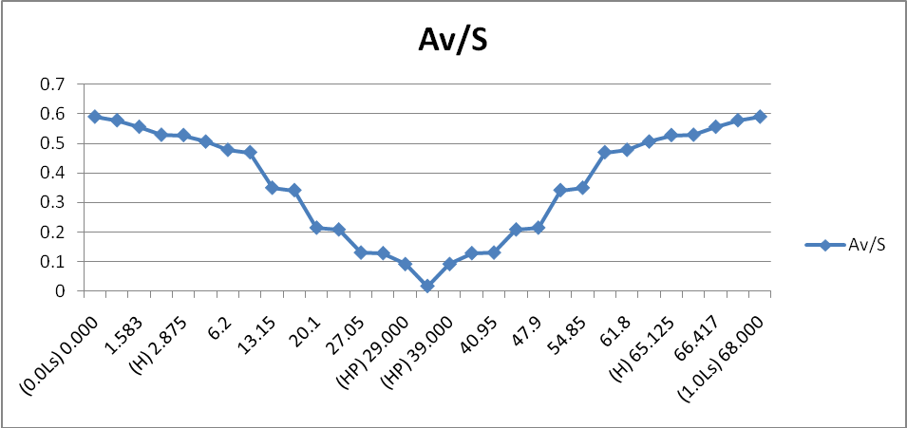
Figure 1 - Av/S Demand for Simple Supports

Demand curves for non-symmetrical loadings are created by enveloping maximum demand about mid-girder. For example, for the continuous structure case shown below, maximum demands lie to the right of mid-span.

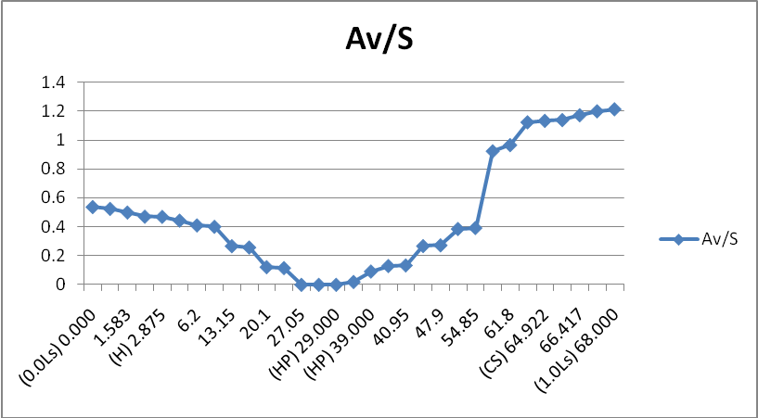
Figure 2 Av/S Demand for Continuous Structure

Large point loads near a support can cause theta to decrease quickly, which abruptly increases capacity because shear is picked up by more stirrups. Hence, the Av/S demand curve can look like below where a large (120 kip) point load is applied at the 0.1 point:
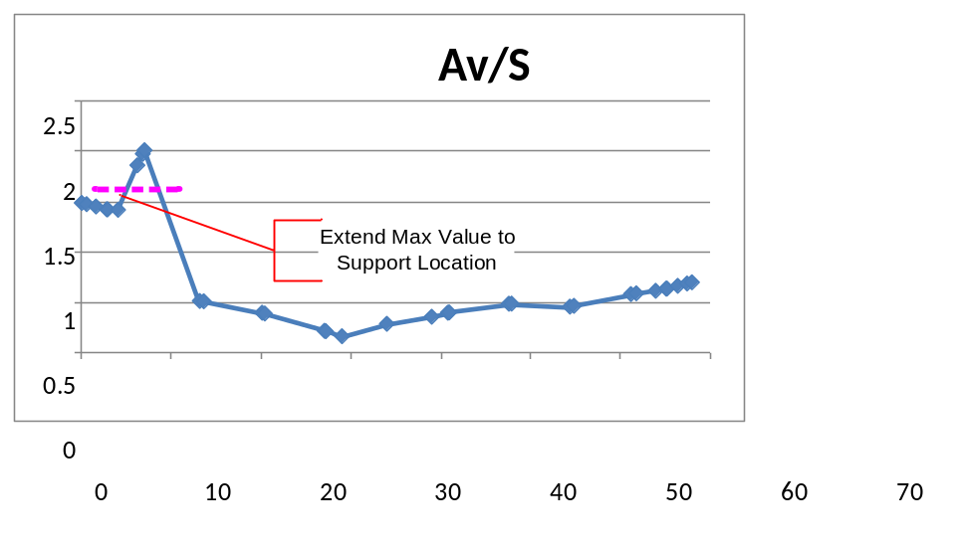
Figure 3 Av/S Demand for Simply Supported Structure with Large Point Load at 0.1 Point

Interpretation of the above graph indicates that stirrup spacing could be increased from the maximum location going left toward the support. However, this is practical for real-world designs.

Another case below shows results for an increasingly large point load applied at mid-span of a simply-supported girder. The graphs are well-behaved until the 40 kip load. Again, it may not make sense to increase stirrup spacing as we approach supports.

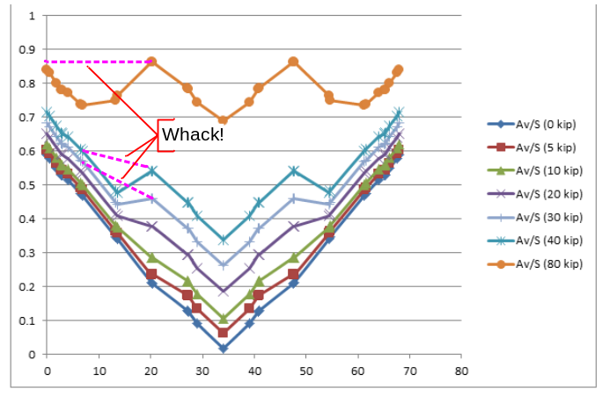
Figure 4 - Av/S Demand with Increasing Point Load at Midspan

Therefore, for cases when the algorithm is to design shear zone layouts, the design algorithm will pre-process all Av/S demand curves as follows:
- Compute “envelope mirror” about mid-girder so max demand from both ends of girder is captured.
- Modify such that Av/S never decreases approaching support locations. The red dotted lines in the figures above show how this would be handled (whacked) for these particular cases.

This process is shown in flow chart A.2.3.

Efficient, Constructible Design
For a typical girder there are infinite possible stirrup layouts that could pass all specification checks. What constitutes an “optimal” design is very dependent on the specific engineer, agency, and girder-type. Hence, the design algorithm must provide users more control information (hints) to determine an “optimal” practical design. These hints can be as simple as specifying a suggested bar size or as complex as predefining details for the entire stirrup layout. This section explores the options to be provided to allow user control of stirrup layouts.

Allowable Stirrup Layouts
Stirrup layouts generated by the design algorithm must abide to PGSuper’s stirrup layout input. Although the UI allows non-symmetrical zone layouts, the zone layout algorithm will always generate symmetrical zones for simplicity. Layout rules are as follows:
- For primary stirrup bars; bar sizes, legs, and spacing are contained within any number of non-overlapping zones
- Each zone contains a single bar size and spacing. The number of legs for vertical shear and horizontal interface shear can be defined separately.
- All zones but the middle zone have a fixed length
- The middle zone grows/shrinks with girder length
- Zones cannot overlap

Top-Level Design Options
This section describes the top-level design options presented to the user and basic guidelines about the options. Refer to the design flowcharts for more information.

Start With Existing Stirrup Layout
Many agencies have standard plans that specify details for stirrup layouts. These details are time-tested for durability and have been optimized for constructability. Hence, the layouts should not be altered unless there is very good reason for doing so (e.g., failure to pass a specification check).

Another scenario may be a user who wants to input non-symmetrical zone boundaries and have the algorithm compute required stirrup sizes/spacings within.

The primary intent here is to retain the existing design data unless it fails a specification check. If the current stirrup layout fails a specification check, design using the following rules (in order of importance):
- Do not alter lengths or number of existing stirrup zones
- Tighten stirrup spacing using existing bar size up to minimum allowable spacing.
- If needed, increase bar size/number of legs per the allowable options.

If bar sizes, spacing, or number of legs must be modified, use the control data/rules defined in paragraphs 3.2.3.3.

A simplified flow chart is given in appendix A.1.5

If any data in an existing stirrup layout was changed, present an obvious message stating such.

Side Note: Zones Input with No Stirrups
In PGSuper it is valid to input stirrup zones that contain no stirrups by specifying “none” as the bar size. If this is the case, the design algorithm will retain the user-input zone boundaries and design bar sizes and spacing within as needed.

The most radical case for this is if no shear data is defined. In the UI there is always one shear zone with no stirrups. Hence, the design will result in a single zone with constant bar size and stirrup spacing across the entire girder.

Start Design from Scratch
(True or False) When this option is selected, the design algorithm chooses the number and length of transverse reinforcement zones, and stirrup sizes and spacing within each zone. Based on the previous discussion about symmetry of Av/S curves, zone layouts will always be symmetrical. When designing zones from scratch, the algorithm will insure that zone lengths are rounded to a whole spacing increment (except for the middle zone).

An algorithm for determining bar sizes and spacings is given in section 2.1. Algorithms and data for determining stirrup zone layouts and bar sizes and spacings are described in the following sections.

Input Data to Control Stirrup Layouts
As mentioned in previous sections, more information is required to provide better control over stirrup and stirrup zone layouts. This section describes the data to be used in the algorithms defined in the appendices of this document. Note that some of the data defined in this section may not be made available in the UI.

Available Stirrup Bar Size and Number of Legs
This data provides a list of pairs of bar size/numbers of legs available to the design algorithm for primary stirrup bars. (e.g., #4(2 legs), #5(4 legs)). Ordering of the list defines the user’s priority in which bars are selected by the algorithm. Note that it is the user’s responsibility to determine if the bars specified can actually be bent into stirrups for the section being designed.

Allowable Bar Sizes for Confinement Reinforcement
A list of bar sizes that can be used for confinement reinforcement. This is an internally hard-coded value - #3’s will be used.

Available Stirrup Spacing Increments
A list of available stirrup bar spacings to be made available to the design algorithm (e.g., 2”, 2.5”, 3”, 6”, 9”, 12”, 18”, 24”). Note that the algorithm will not use a spacing from this list if it lies outside of the allowable spacing defined in the Project Criteria.

Use Homogeneous Bar Sizing
(True or False) If true, the algorithm will attempt to design all primary stirrups using the same bar size.

Maximum Change in Bar Spacing between Zones
(Real Number) Large jumps in bar spacing between adjacent zones may result in stress concentrations. This number limits how much bar spacings can change between zones.

Maximum Change in Shear Capacity between Zones
(Real Number) Large jumps in Av/S between adjacent zones may result in stress concentrations. This number limits how much Av/S can change between zones.

Minimum Number of Spacing Increments per Zone
(Integer) Creating a stirrup zone with a single spacing is undesirable. This number says that there must be at least N spacings in any given zone.

Minimum Zone Length
(Real Number) Zones with very short lengths are undesirable. The number defines the minimum length for any zone.

Design Control Data

Design for Splitting
(True or False) Instruct the design algorithm whether or not to design for splitting.

Design for Confinement
(True or False) Instruct the design algorithm whether or not to design for confinement.

Top Flange Intentionally Roughened for Interface Shear Capacity
(True or False) This value will be taken from the project criteria library.

Extend all Primary Bars into Composite Deck
(True or False) If true, all legs for primary bars will be extended into the deck to provide resistance for horizontal interface shear. This value will be taken from the project criteria library.

Primary Bars Provide Splitting Capacity
(True or False) If true, primary bars are used for splitting capacity. If false, additional splitting bars will be used. This option is disabled if splitting design is turned off. For from-scratch designs, this value will be taken from the project criteria library, otherwise it will be taken from project data.

Primary Bars Act as Confinement Reinforcement
(True or False) If true, primary bars are used for confinement capacity. If false, additional confinement bars will be used. This option is disabled if confinement design is turned off.

Options for Longitudinal Reinforcement for Shear Design
Two possible options are available to provide capacity for LRFD 5.8.3.5.
- Add prestressing strands. Note that if prestressing strands are added, this will trigger a flexural re-design with the new value as the minimum number of strands.
- Increase mild-steel reinforcement. This will be added at either the top of bottom of the girder in question.

Questions/Open Issues
Currently there are no unresolved open issues.

However, the following are possible risks to the design that have been discussed and resolved, but may bear their ugly heads at some point in the future:

- PGSuper places POI’s at 1/10th points and several other special locations (FOS, CS, H, 1.5H, HP, user-load locations, others…) for design and checking. This may not be fine-grained enough for someone seeking a highly-tuned stirrup zone layout. Also, values will need to be interpolated if no POI exists at an existing zone boundary. The good news is that this should adequate to pass all of PGSuper’s specification checks. Should we consider adding more POI’s for the shear design algorithm? If so, at what increments?
- To compute capacity, PGSuper currently uses the bar size/spacing directly at a POI. It does not look further out in the 0.5*dv*cot(theta) regions on either side. C5.8.3.2 shows a way to avoid this by grabbing all stirrups within a distance 0.5dv*cot(theta) from the POI. I'm not sure that this is the ideal way to go, but I want to send out an alarm that what we have not may not be a conservative way to go.Is this OK? See comments 3225- in Bugtracker issue #111 for more insight into this issue.

Description of the Appendices
The design algorithm flowcharts are in the following Appendices:

Appendix A – Shear Design Flowcharts

